**Fabric Notebook**

A **Fabric Notebook** is a web-based interactive environment in Microsoft Fabric that allows users to write and run code using languages like **Python**, **SQL**, and **Spark** for data exploration, transformation, machine learning, and visualization—integrated seamlessly with One Lake and other Fabric components.

• Add **Data Items**:  
Use this option to bring in your data sources (e.g., Lakehouse tables).

• Run **All**:  
Executes all the code cells at once using the **Run All** button.

• Connect:  
Link the notebook to a compute pool (default: **Starter Pool** or a custom one).

• Select **Language**:  
You can choose languages like **PySpark**, **SQL**, etc. (PySpark is used here).

• Write **Code**:  
This is where the actual data processing logic is written.

**Starter Pool in Fabric**

A **Starter Pool** is:

* A **pre-warmed Apache Spark cluster** in Fabric.
* **Instantly available**, so no wait time to spin up compute.

**Key Features:**

* **No Setup Needed** – Comes ready to use.
* **Fast Startup** – Because it's already running, it executes notebooks quicker than cold-start Spark clusters.

To create custom session

Load data from data lakehouse to datawarehouse

First we add source as lakehouse to notebook

Click on add data item 🡪existing data sources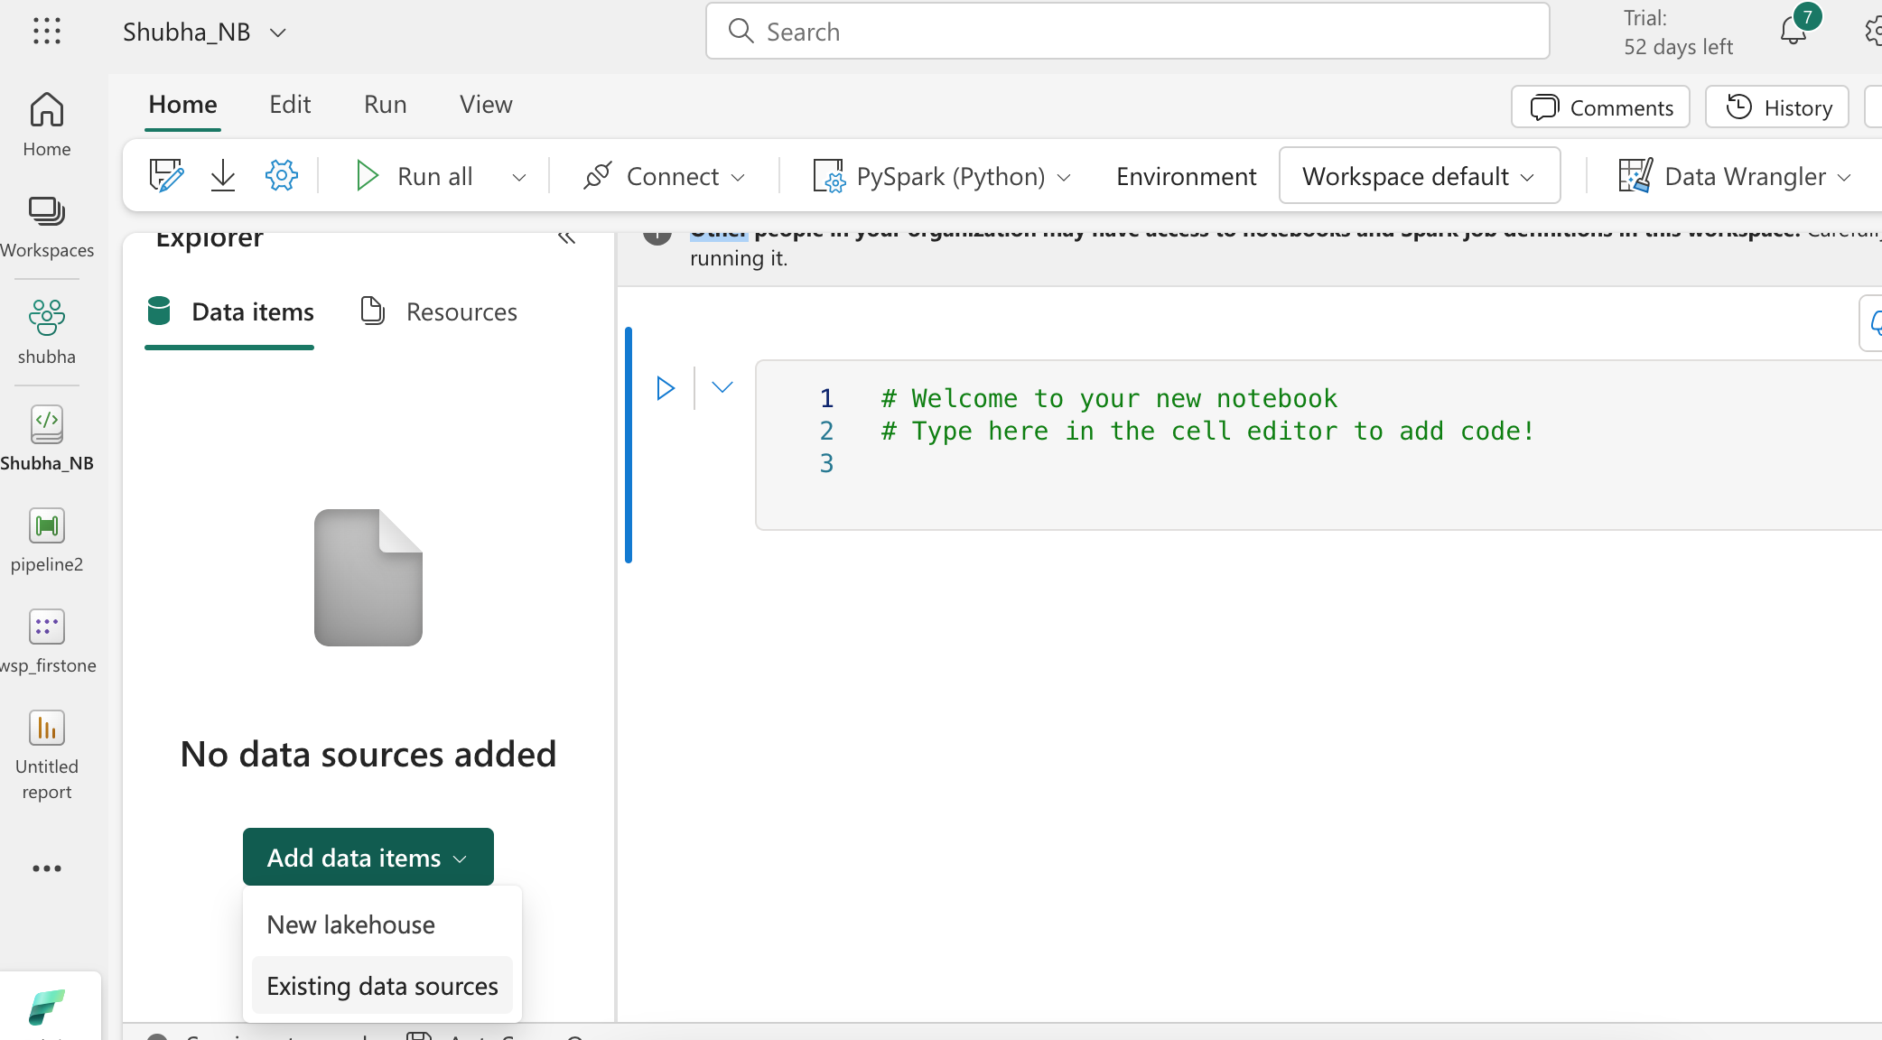Now lets read the data from lakehouse to a dataframe

lets write data into datawarehouse

now we can write the data to warehouse , using below code

**code ran successfully

data got loaded successfully 